Bangladesh University of Professionals



Faculty of Science and Technology
Department of Information & Communication Technology (ICT)

Course Title: Industrial Training

Course Code: ICE-3211

Submitted by

Section – A, Batch: BICE – 2022

Name: Nasrat Jahan
ID:2254901061
Walton ID: IA-539
Submission Date: 09.05.2026

In modern software, applications aren't just one big file; they are broken into small, lightweight pieces called Containers (like Docker). When you have hundreds of these containers, it becomes impossible to manage them manually. Kubernetes is the tool that automates that management.
four main things Kubernetes does in simple terms:
1. The Manager (Self-Healing)
If a container "crashes" or stops working, Kubernetes notices it immediately. It automatically shuts down the broken one and starts a fresh one so your website never goes down.
2. The Traffic Police (Load Balancing)
If your website suddenly gets a lot of visitors (like during a sale), Kubernetes spreads the "traffic" evenly across all your containers. This prevents any single part of your system from getting overwhelmed and crashing.
3. The Scaler (Scaling)
When your app is busy, Kubernetes can automatically add more containers to handle the work (Scaling Up). When the rush is over, it removes the extra ones to save money (Scaling Down).
4. The Time Machine (Roll-outs and Roll-backs)
- Roll-out: When you have a new update, Kubernetes replaces the old containers with new ones one-by-one, so the app stays online during the update.
- Roll-back: If the new update has a bug, you can tell Kubernetes to "go back" to the previous stable version instantly.

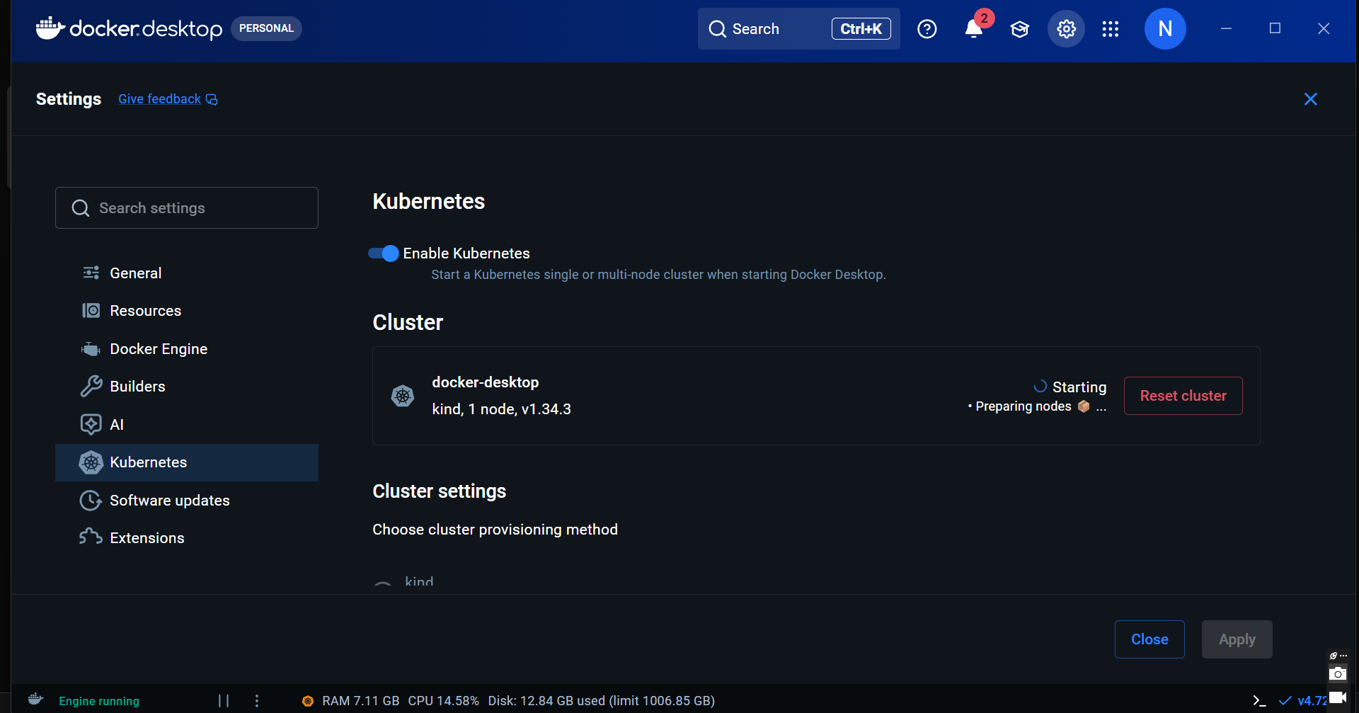
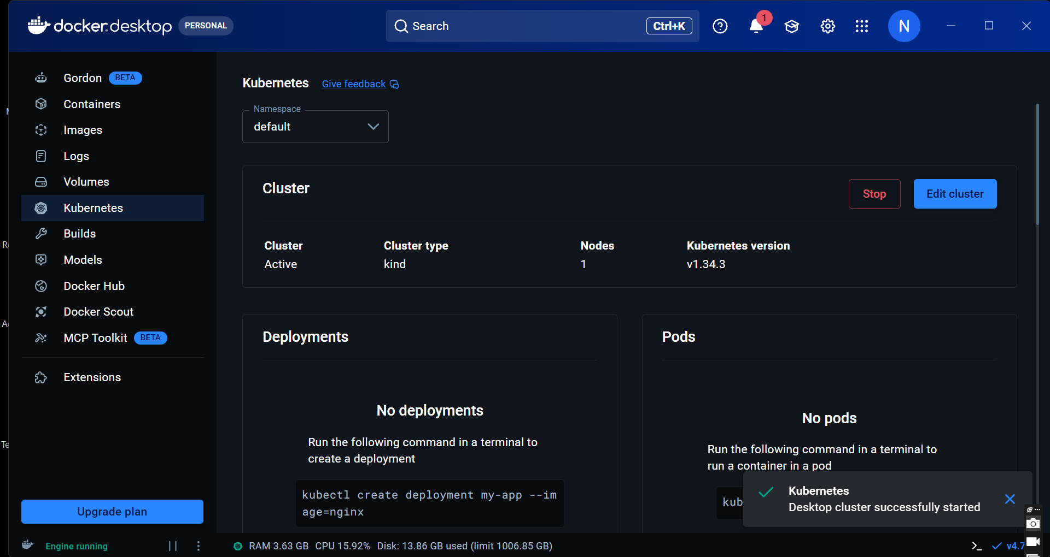
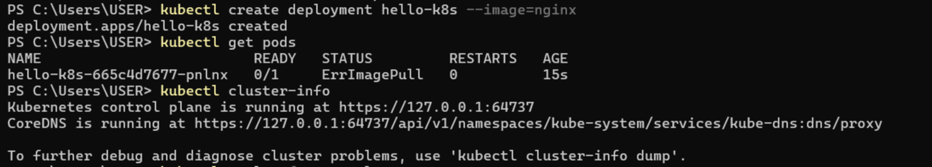
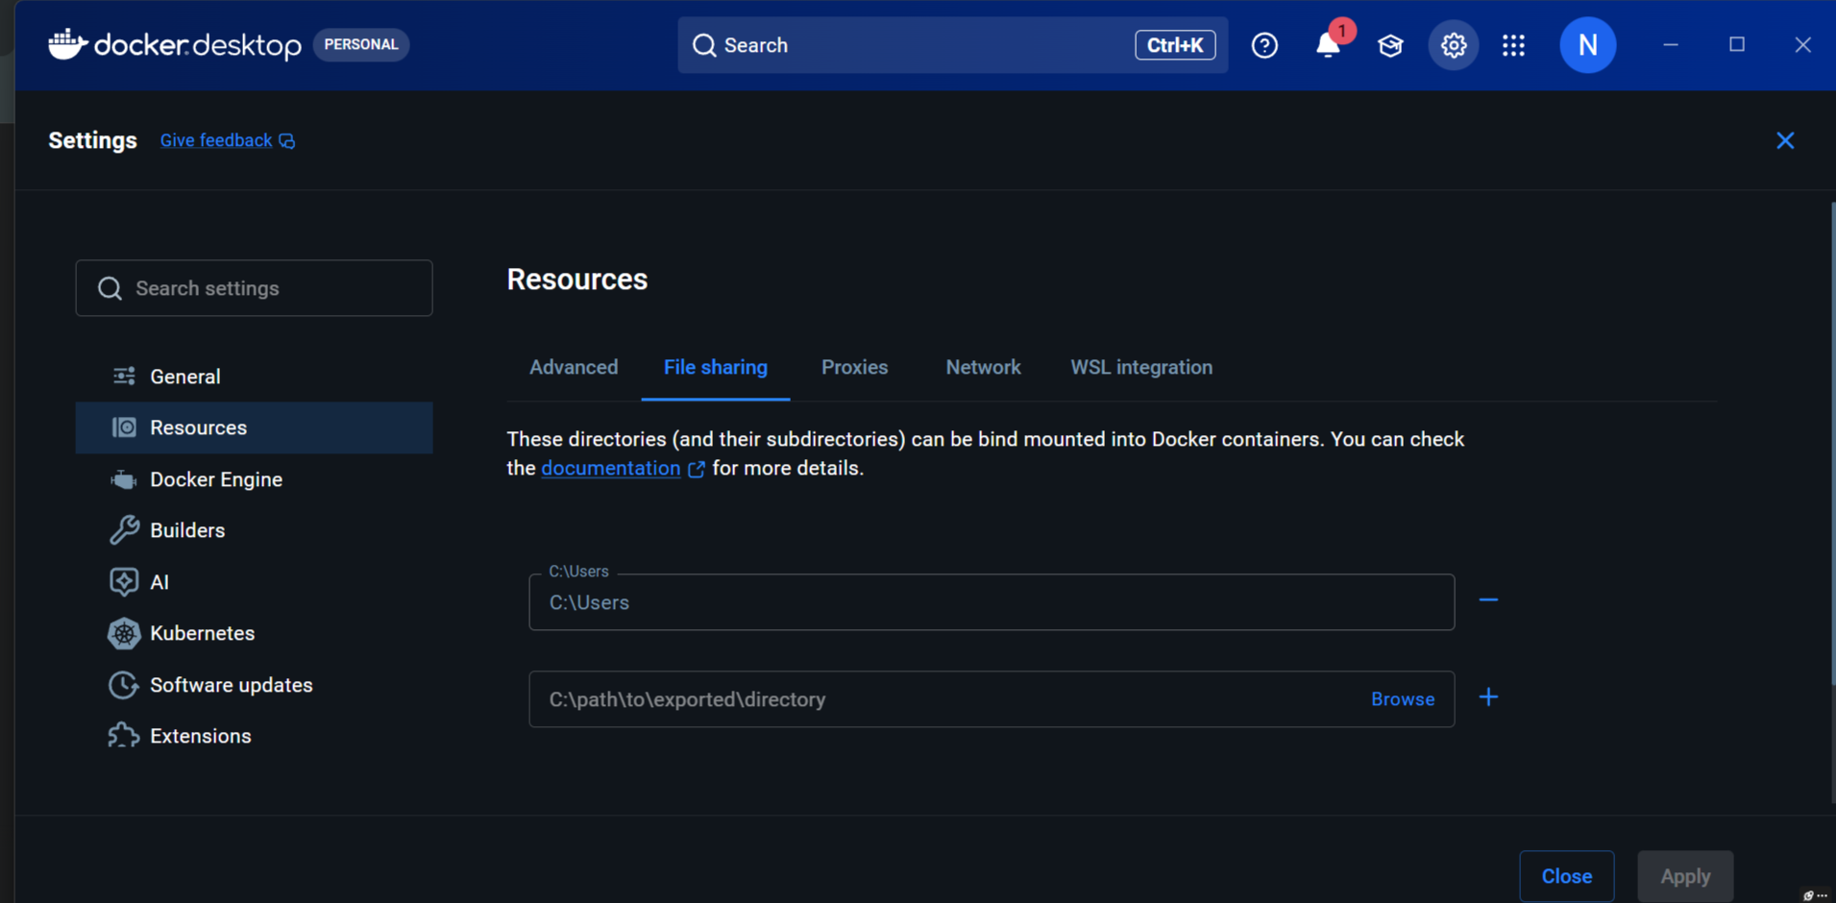
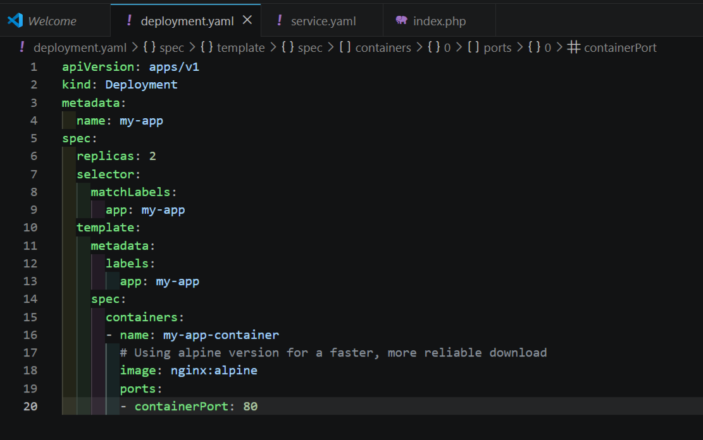
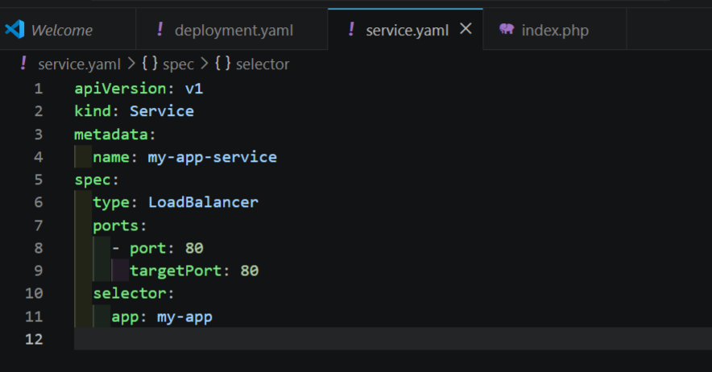
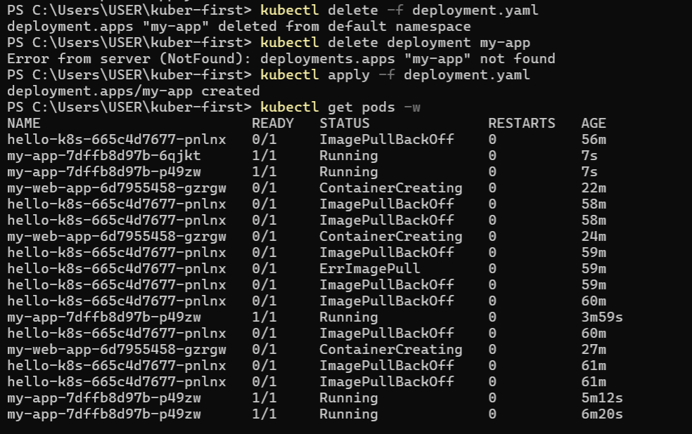
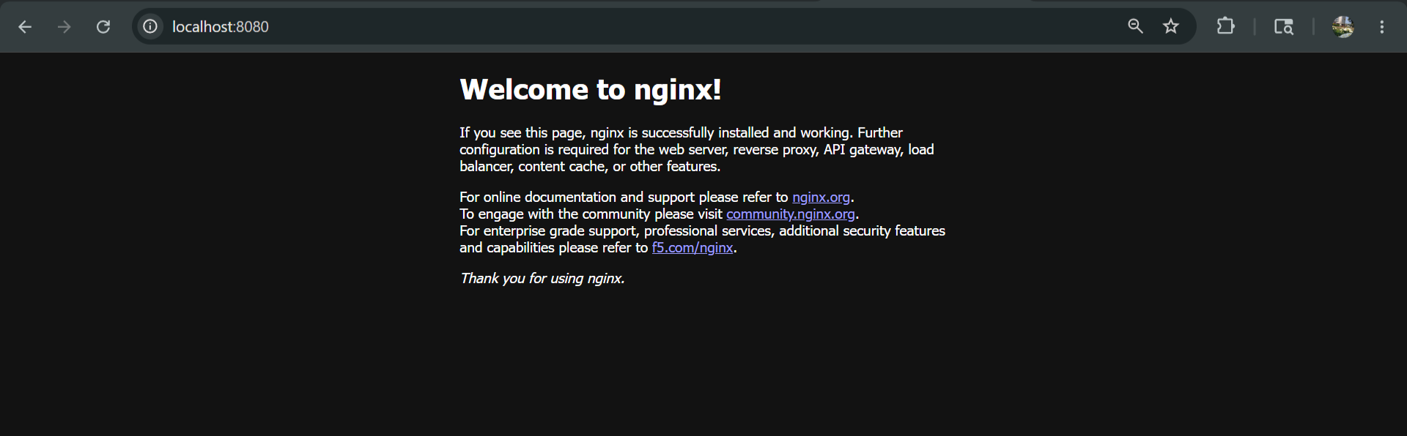
Deployment.yml
apiVersion: apps/v1
kind: Deployment
metadata:
name: my-app
spec:
replicas: 1
selector:
matchLabels:
app: my-app
template:
metadata:
labels:
app: my-app
spec:
containers:
- name: my-app-container
image: nginx:alpine
ports:
- containerPort: 80
command: ["/bin/sh", "-c"]
args:
- |
echo '<!DOCTYPE html>
<html lang="en">
<head>
<meta charset="UTF-8">
<title>Dev Workspace | Kubernetes</title>
<style>
body { margin: 0; display: flex; justify-content: center; align-items: center; height: 100vh; background: linear-gradient(135deg, #1e1e2f 0%, #0f0f1a 100%); color: white; font-family: sans-serif; text-align: center; }
.container { padding: 40px; border-radius: 20px; background: rgba(255, 255, 255, 0.05); backdrop-filter: blur(10px); border: 1px solid rgba(255,255,255,0.1); }
h1 { font-size: 3rem; color: #61dafb; }
.badge { display: inline-block; padding: 8px 20px; background: #4caf50; border-radius: 50px; font-weight: bold; }
</style>
</head>
<body>
<div class="container">
<h1>Kubernetes Active</h1>
<p>Local Environment Bridged Successfully</p>
<div class="badge">PHP & LARAVEL READY</div>
</div>
</body>
</html>' > /usr/share/nginx/html/index.html && nginx -g 'daemon off;'

